MARKS ALLOCATION (60 marks, 20%)
PART A: CORELATION BETWEEN M1 AND M2 |  |  |  | Marks
Criteria | 0 | 1-4 | 5
- Included the approved proposal in Milestone 1 | None | Incomplete and not updated/corrected | Complete and updated/corrected
TOTAL PART A
(5 MARKS)
PART B: SCREENS MAP |  |  |  | Marks
Criteria | 0-1 | 2-3 | 4-5
- Overall screens map | None or poorly screens map provided | Well prepared screens map with minor error | Complete screens map with no error
- Activities | None or insufficient activities | Sufficient activities | Well planned activities
- Application navigation | None or poor/ ambiguous navigation | Acceptable navigation with minor correction | Acceptable navigation with no correction
TOTAL PART B
(15 MARKS)
PART C: SKETCH AND WIREFRAME |  |  |  | Marks
Criteria | 0-1 | 2-3 | 4-5
1. Goal driven design | None or poor design | Partially design for the right user, acceptable workflow that suits their needs | Design for the right user, acceptable workflow that suits their needs
- Learnability | None or unable to learn to use the application | User is partially know how to use the interface and the interface nature is partially familiar to the user | User is instinctively know how to use the interface and the interface nature is familiar to the user
 | 0-5 | 6-10 | 11-15
- Sketch UI design | None or sketch UI designed in very minimal | Sketch UI designed in brief | Sketch UI designed in detail with labels
- Wireframe / Application navigation based on the screens map in Part B | None or poor/ ambiguous navigation | Acceptable navigation with minor unmatched | Navigation in the wireframe matched with the screens map
TOTAL PART C
(40 MARKS)
TOTAL M2
(PART A + PART B + PART C)
(60 MARKS)

Instruction: Plan and design your application by completing required information in the provided table.
Milestone 2 requires you to plan and design your application. The design should be based on the proposal in Milestone 1. You are going to illustrate the design of the proposed application.
Your application must be original, not inherited from any existing application, not using template from the third party, and must be different among each other.
Main requirement of your application:
Requirements | Descriptions
Icon | A custom icon that reflects your application
Splash Screen | A welcoming page that will auto navigate to the home screen
Pages | Some pages to represent your application features
Storage | Apply local file or online database storage
About Page | A page that consists of the application description, developer, version

This assignment is an individual assessment. You may refer to Chapter 2 and Lab 1 for examples and guideline in completing this assessment.

PART A: CORELATION BETWEEN M1 AND M2
Complete the following table based on the corrected Milestone 1.
Application Name | ShareNest – Smart Community Asset Sharing
Application Description | ShareNest is a smart community asset-sharing platform designed for residential neighborhoods and apartment complexes. It digitally connects neighbors who need to borrow household tools and equipment with residents who are willing to share unused items. Instead of relying on unorganized messaging groups, ShareNest provides a structured community catalog, real-time availability, digital booking, condition records, and deposit tracking. By using digital tools to coordinate the sharing of underused resources, the application encourages collaboration within the community, reduces unnecessary purchases, and makes shared assets easier and safer to manage.
Objectives | 1. To connect community members who want to lend or borrow household tools and equipment.  2. To manage item availability and borrowing reservations through a digital booking system.  3. To record item conditions, deposits, and borrowing history to make community sharing safer and more organized.  4. To promote smart community resource sharing by helping users reuse available items instead of buying them unnecessarily.
Target user | 1. Apartment Residents – People living in apartments who need tools or equipment but do not want to buy or store them.  2. Suburban Homeowners – Homeowners who may need items such as drills, ladders, pressure washers, or moving equipment.  3. DIY Hobbyists and Gardeners – Community members who own useful tools and are willing to lend them to neighbors.  4. Neighborhood Asset Owners – People who have unused household equipment and want to share it safely with other community members.
List of Features with its Description | - Community Tool & Asset Catalog: A browsable, categorized repository of neighbor-listed items (Power Tools, Yard Work, Event Supplies, Moving Gear) with a search bar, filter chips, item thumbnails, deposit amount, and a live Available/Borrowed status badge on every listing.  - Item Details & Owner Profile: A detailed view for each item showing a photo carousel, specs and usage rules, the listed deposit amount, the owner's name and trust rating, and a "Message owner" option before committing to a reservation.  - Smart Reservation & Calendar Scheduler: An integrated booking system where neighbors select pickup and return dates on a calendar, see already-booked days greyed out, choose a pickup time slot, and view the deposit and late-return fee before confirming.  - Add Listing (Lender Flow): A guided form for neighbors to list their own items — photos, name, category, description, deposit amount, searchable tags, and a visibility toggle — with a preview step before publishing.  - My Bookings & Borrowing Schedule: A dashboard split between "Borrowing" and "Lending" views, showing upcoming pickups, due-back reminders, and active reservations at a glance.  - Pre- & Post-Loan Condition Handover Log: A dual-sided verification flow where both lender and borrower upload a condition photo, add notes, sign off with a checklist, and get a timestamped record — preventing disputes over item condition.  - Security & Deposit Trust Tracker: A record-keeping module that shows deposit status (held/returned), a step-by-step timeline (Reserved → Picked Up → Returned), a refund breakdown, a neighbor trust rating prompt, and an option to report an issue.  - Borrowing History & Activity Dashboard: A dashboard summarizing active borrows, items lent out, items due soon, and total loan history, with a simple visual chart of monthly borrowing activity.  - User Profile & Account Management: A profile screen showing the user's trust score, contact info, their own listings, account settings, and sign-out — plus a login/register flow with email, password, and social sign-in options.

PART B: SCREENS MAP
Draw a screens map of your proposed application. This screens map should cover overall activities in your application. Place your screens map into the following field.
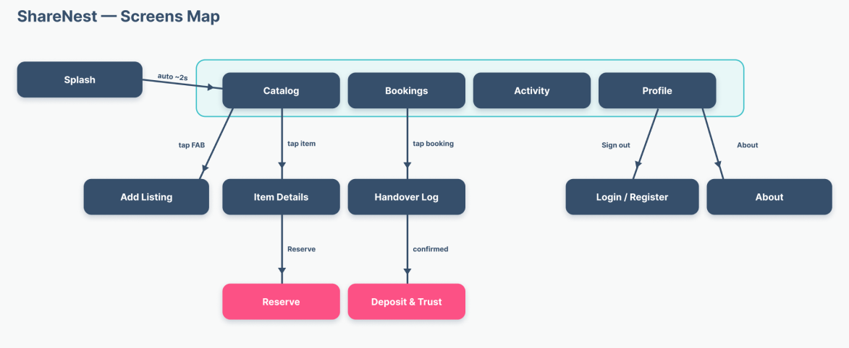

PART C: SKETCH AND WIREFRAME
Based on the screens map and Milestone 1:
- Sketch the design of each activities/page of the proposed application. Explain the elements consist in it. You may also use label to show each element.
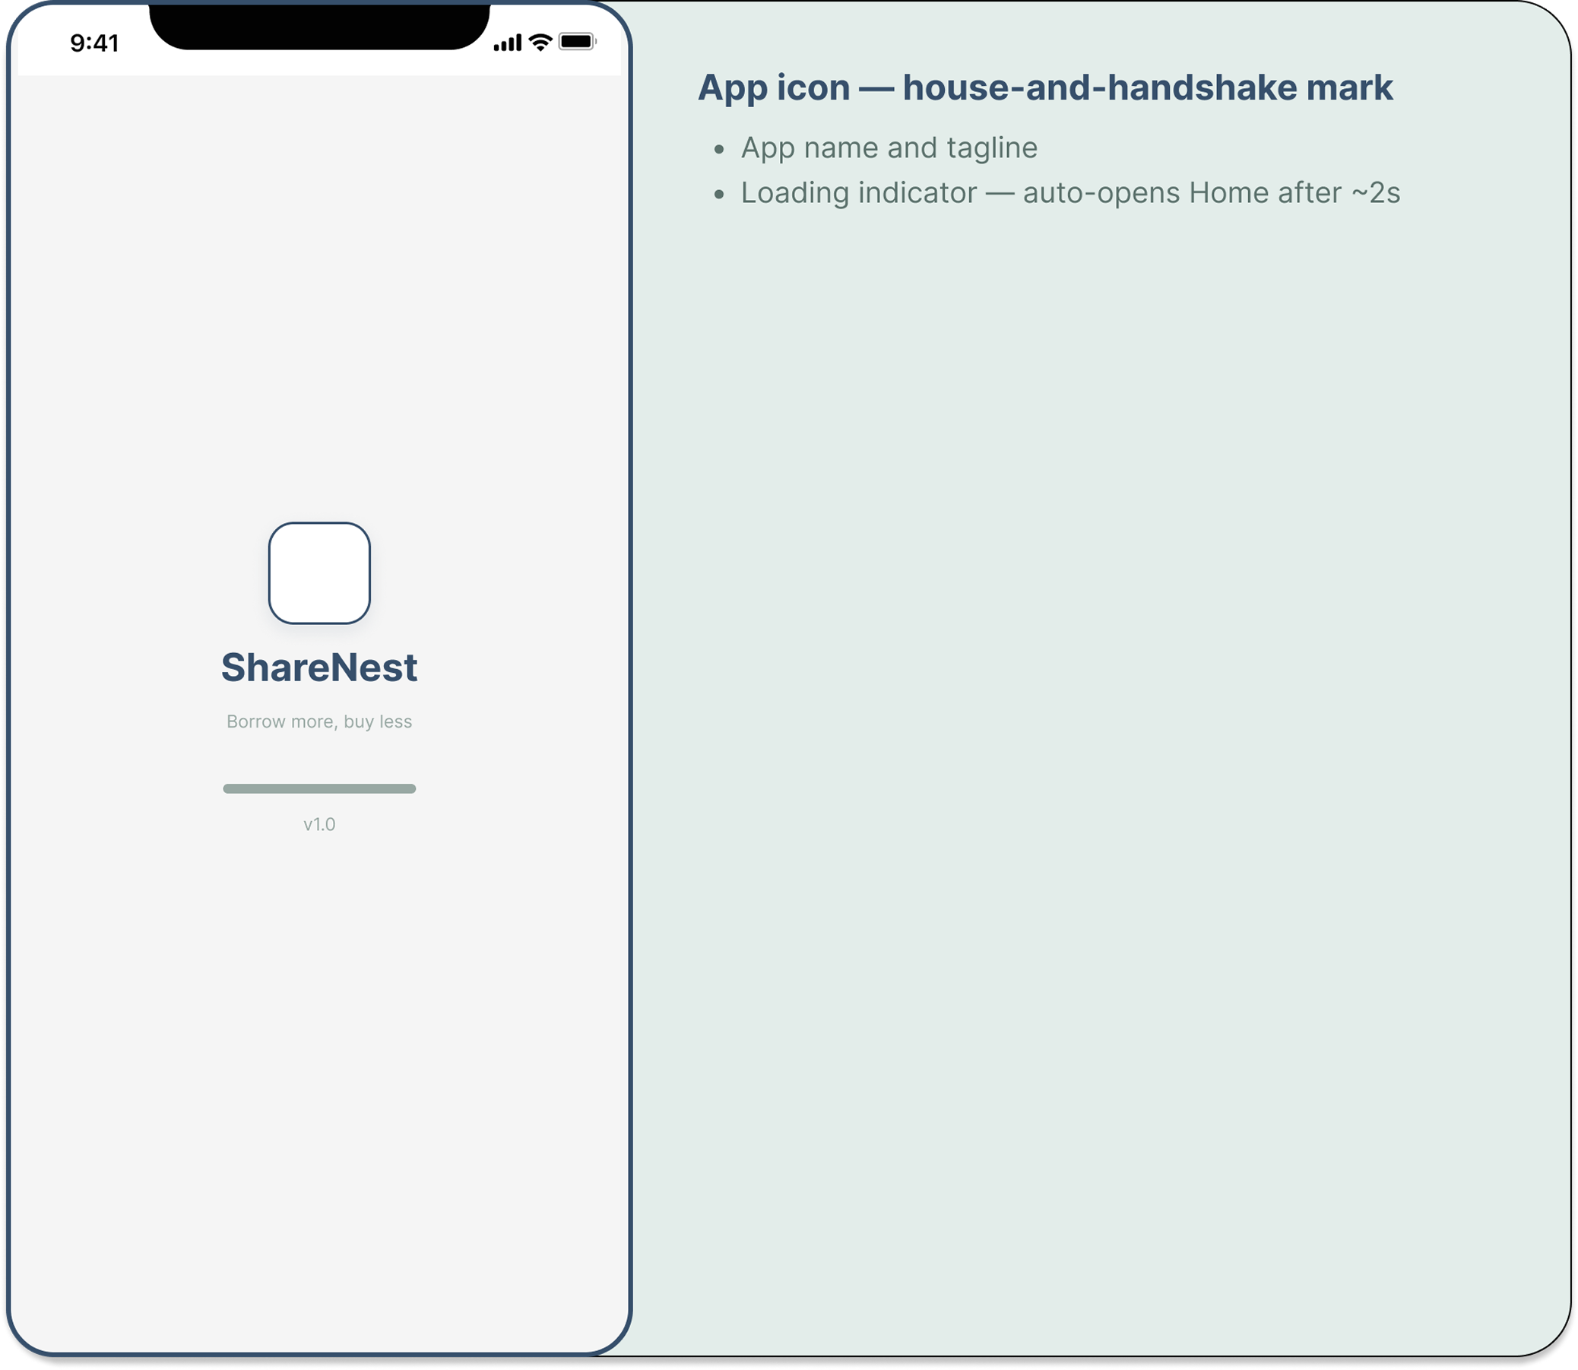
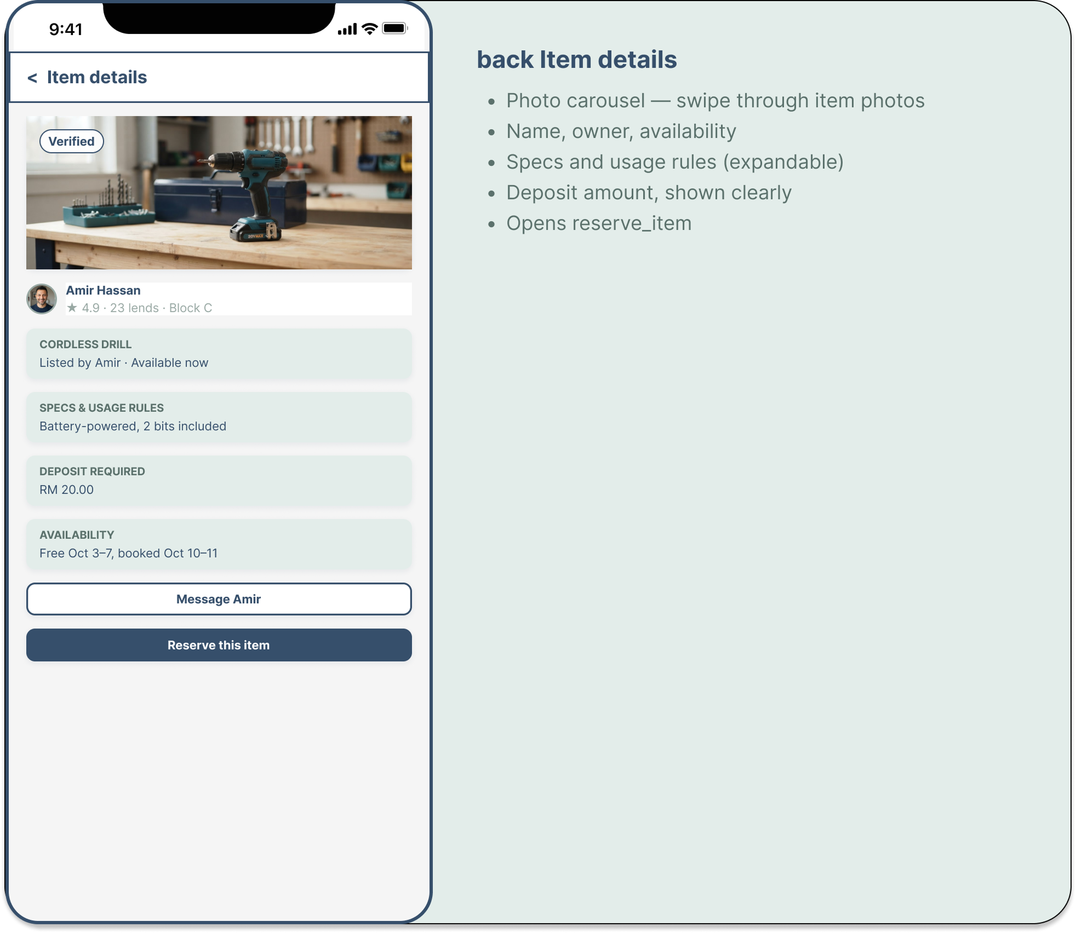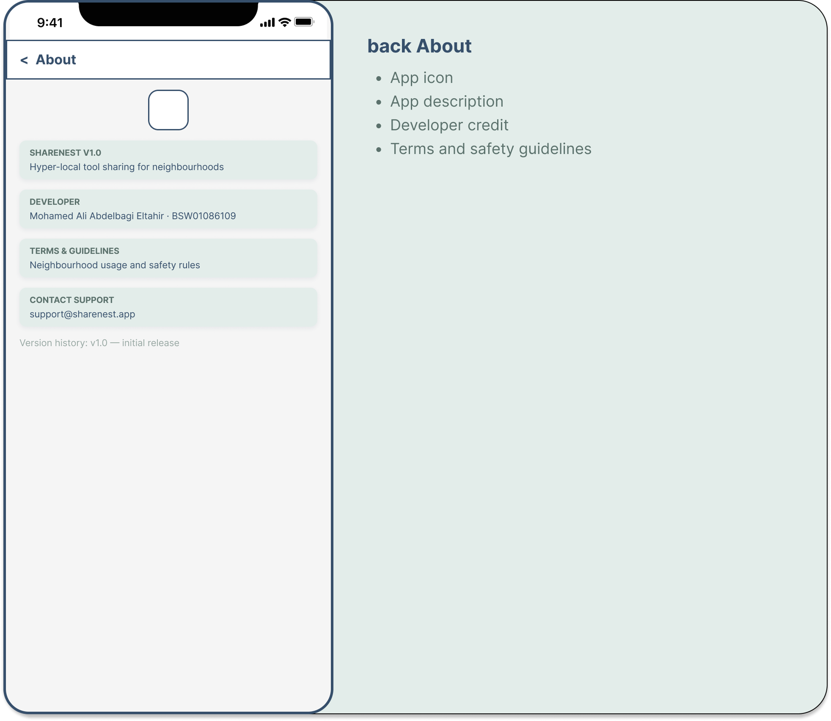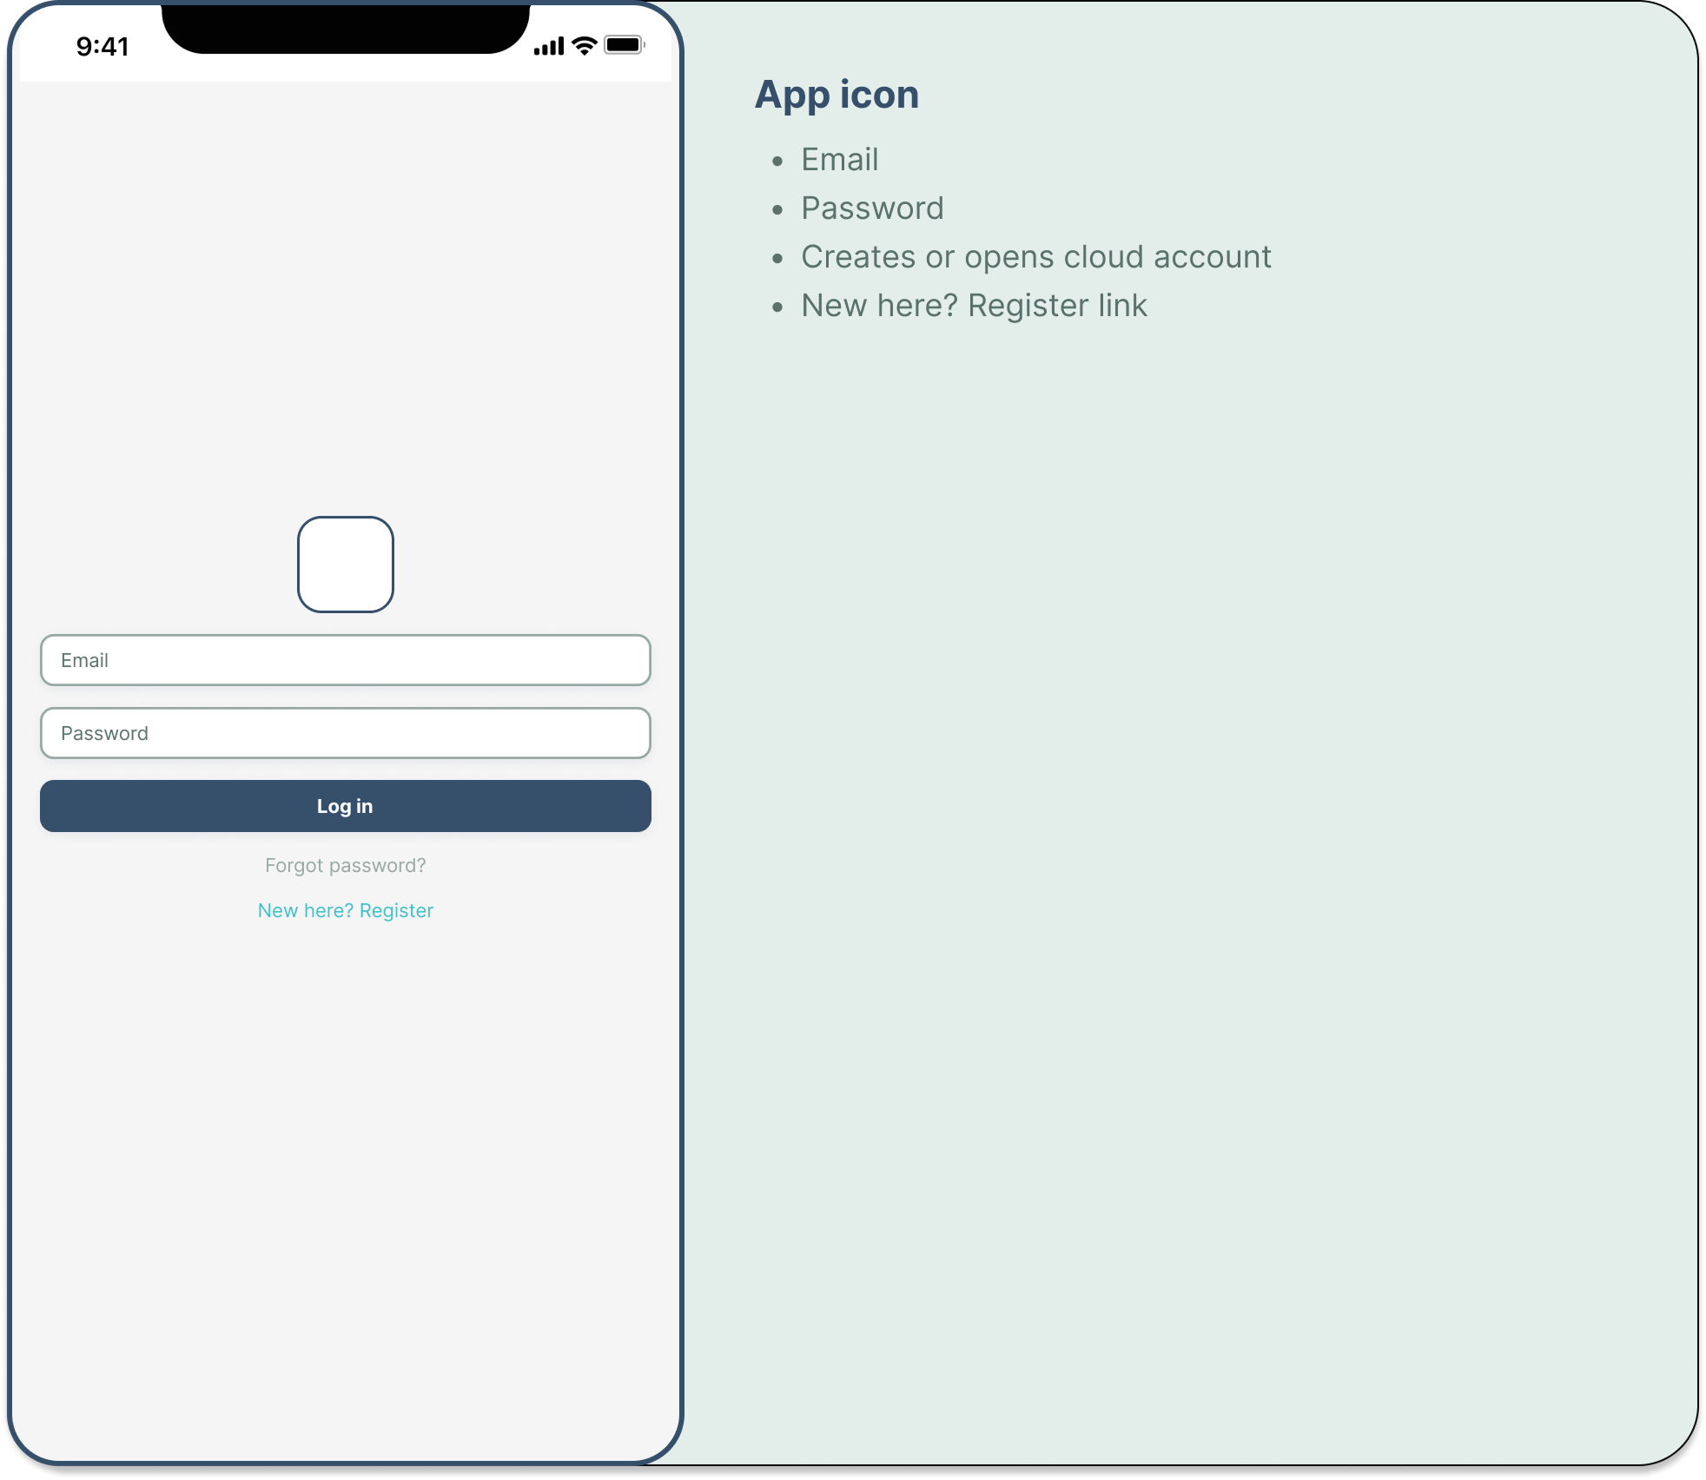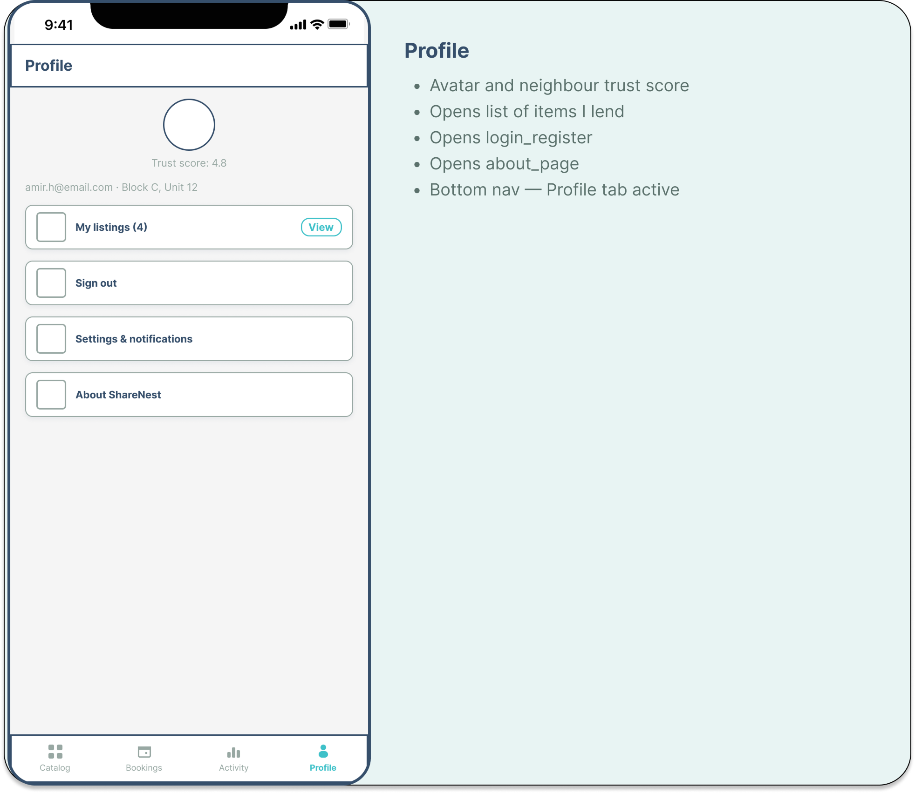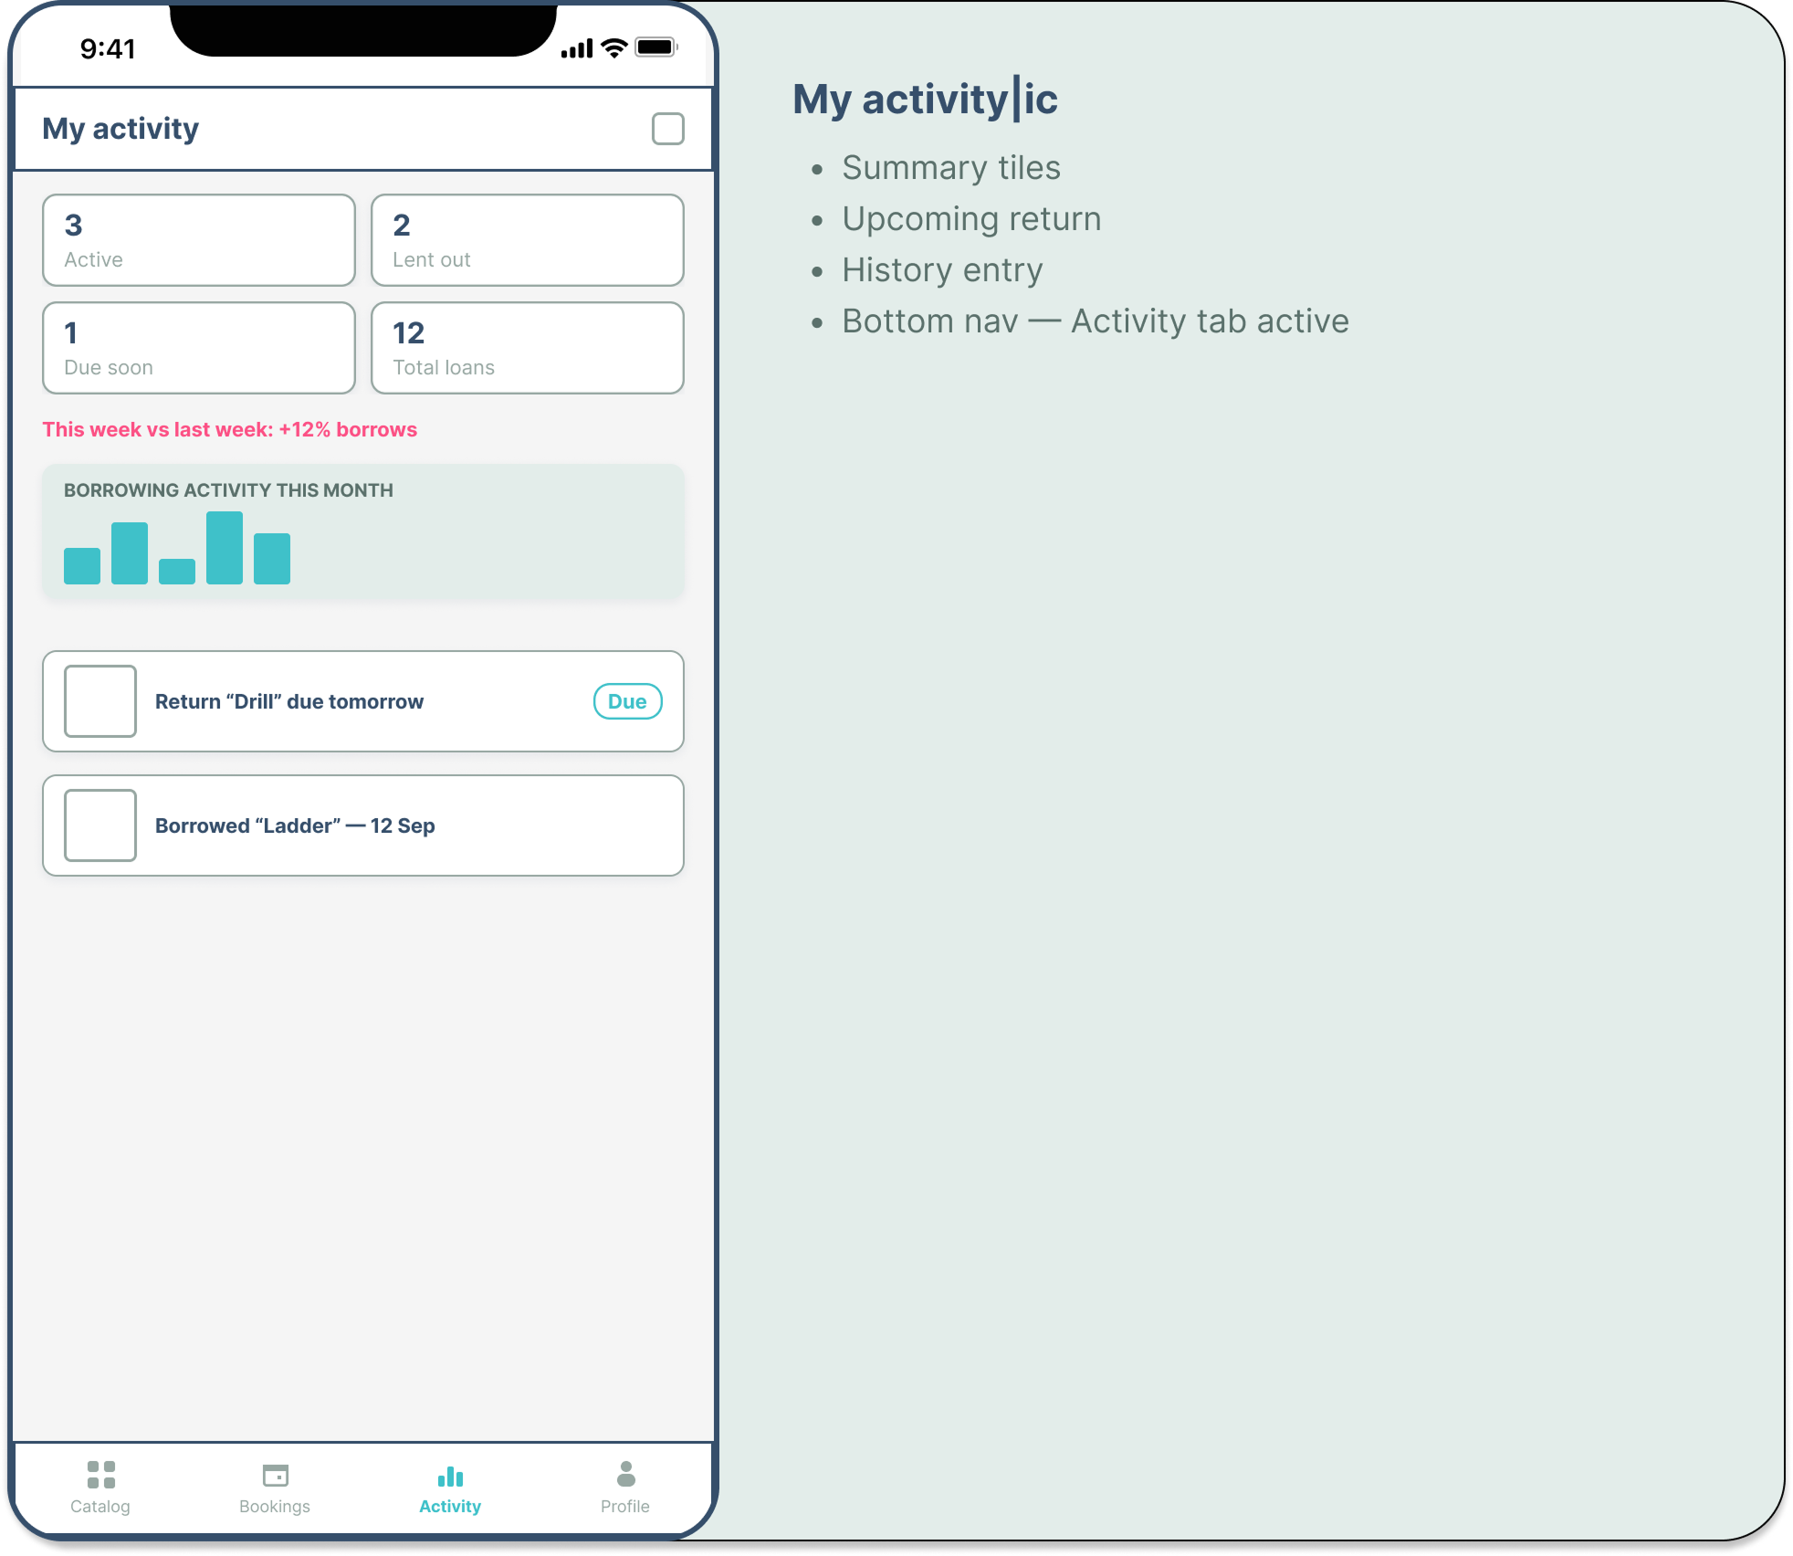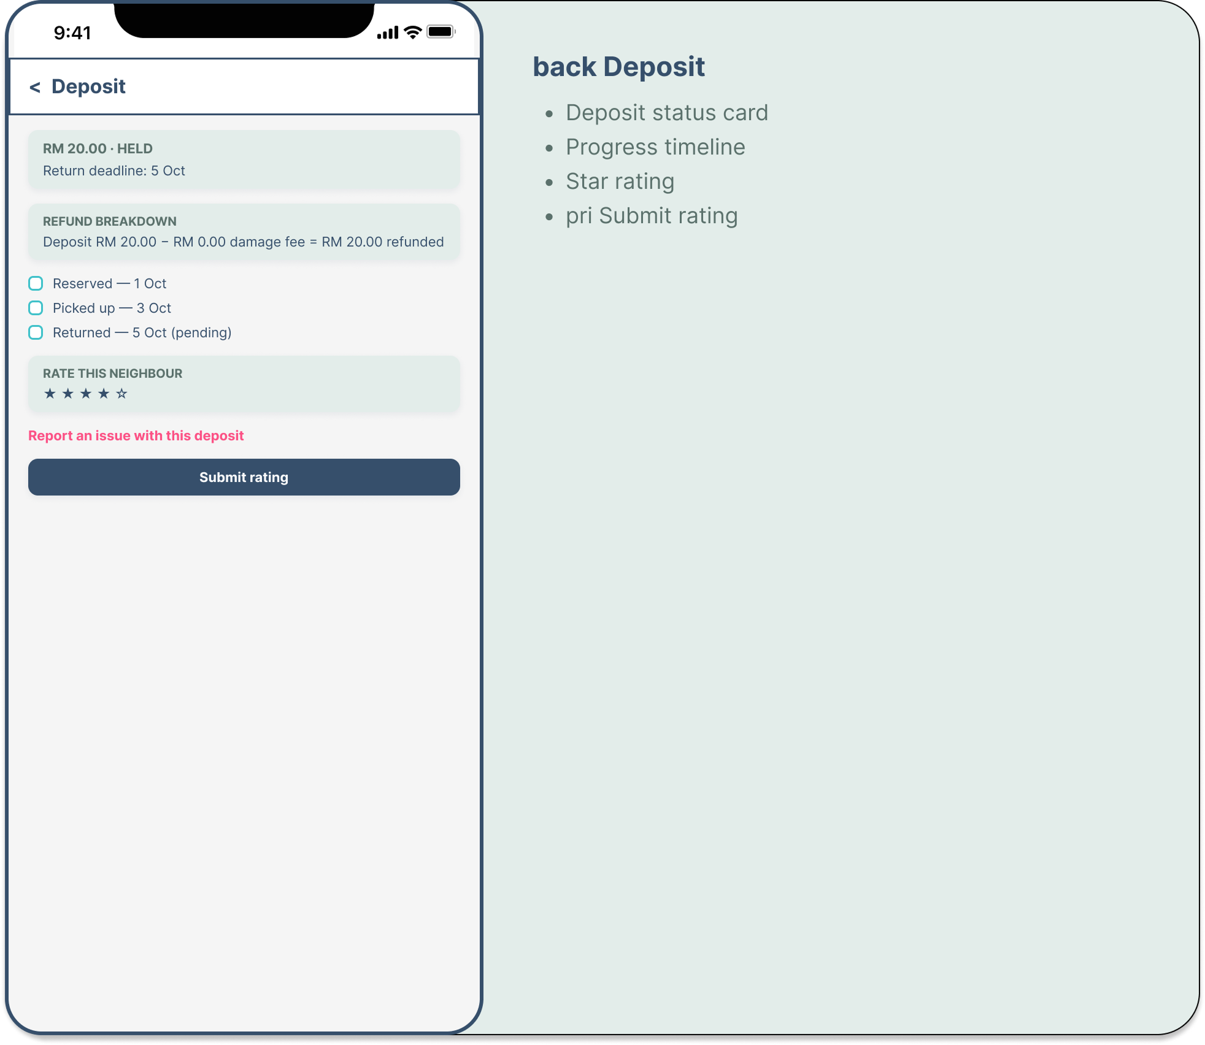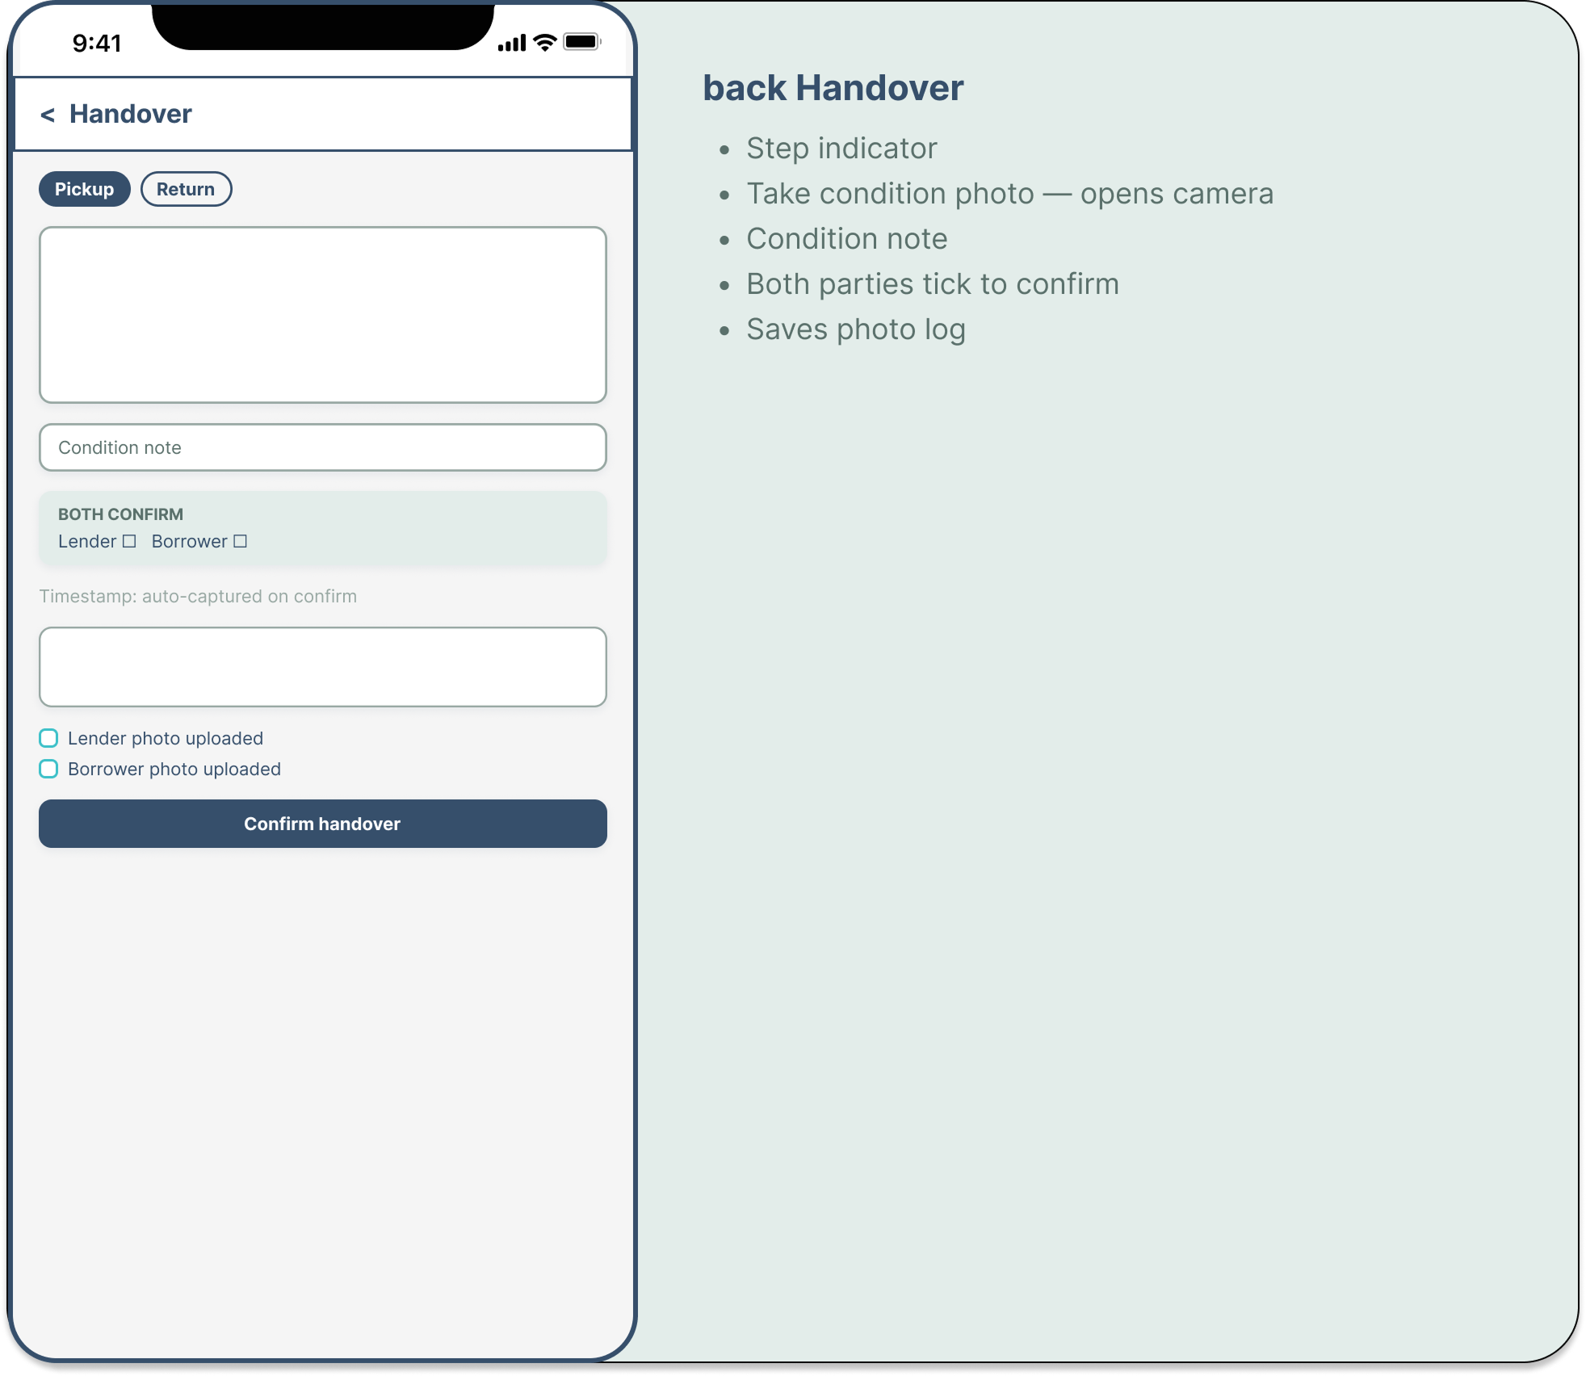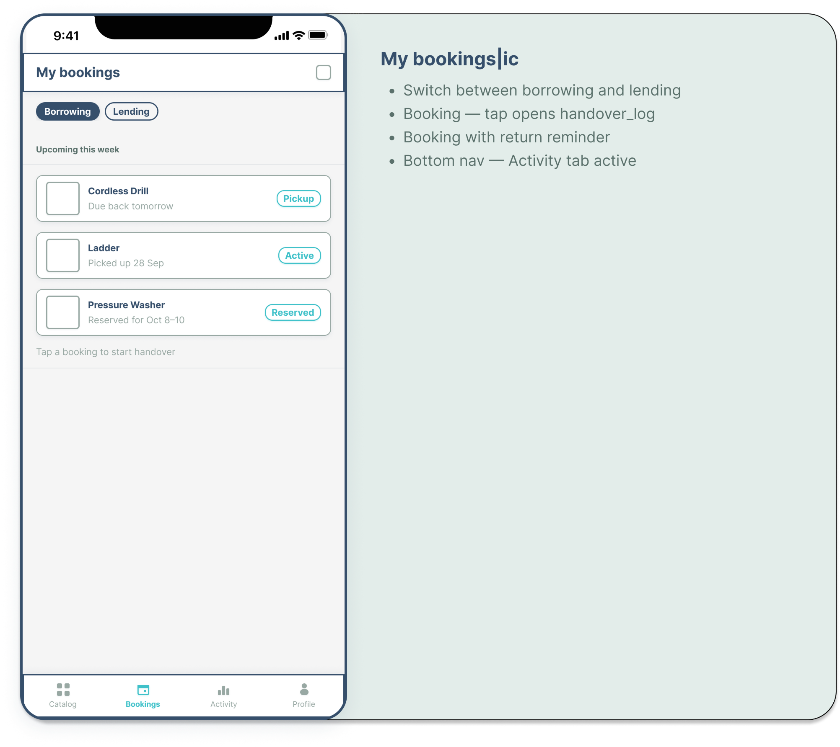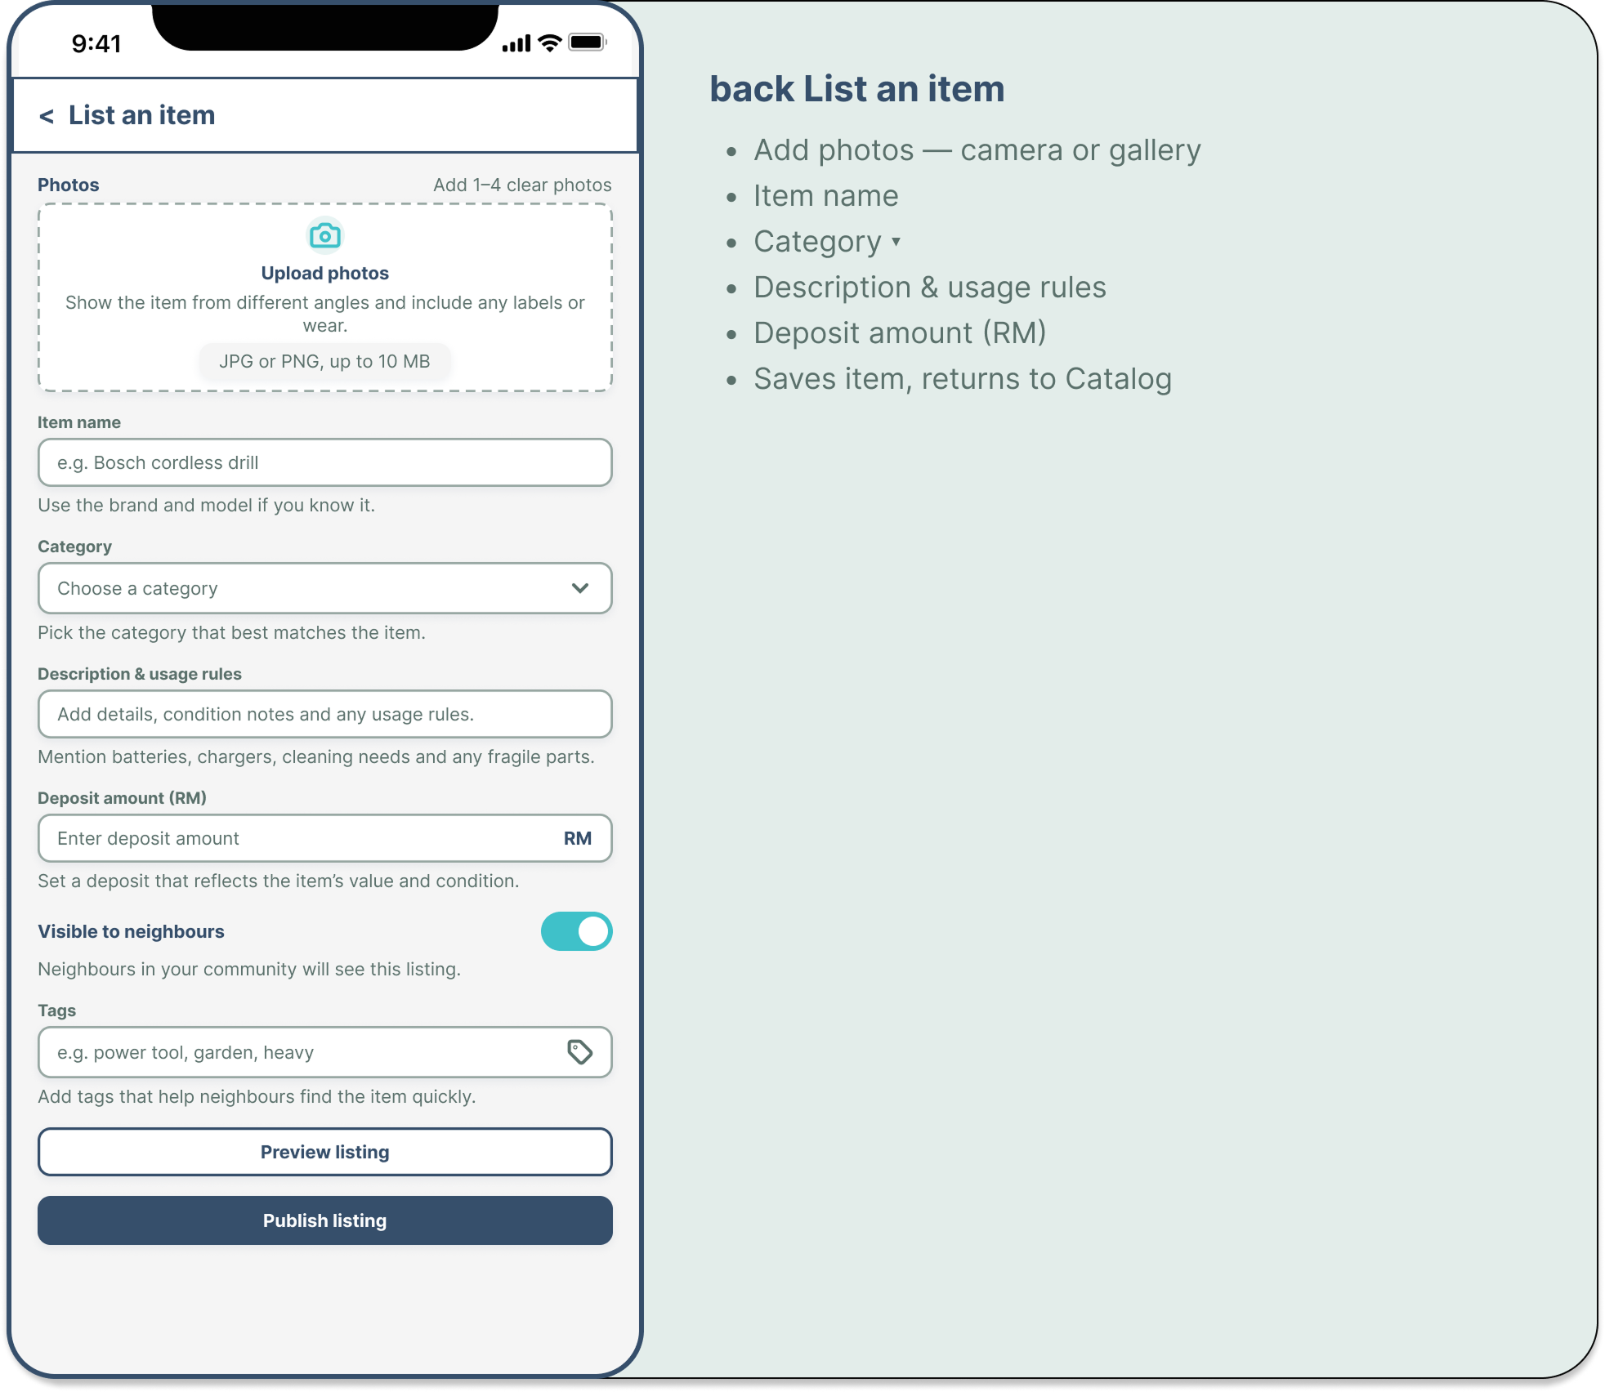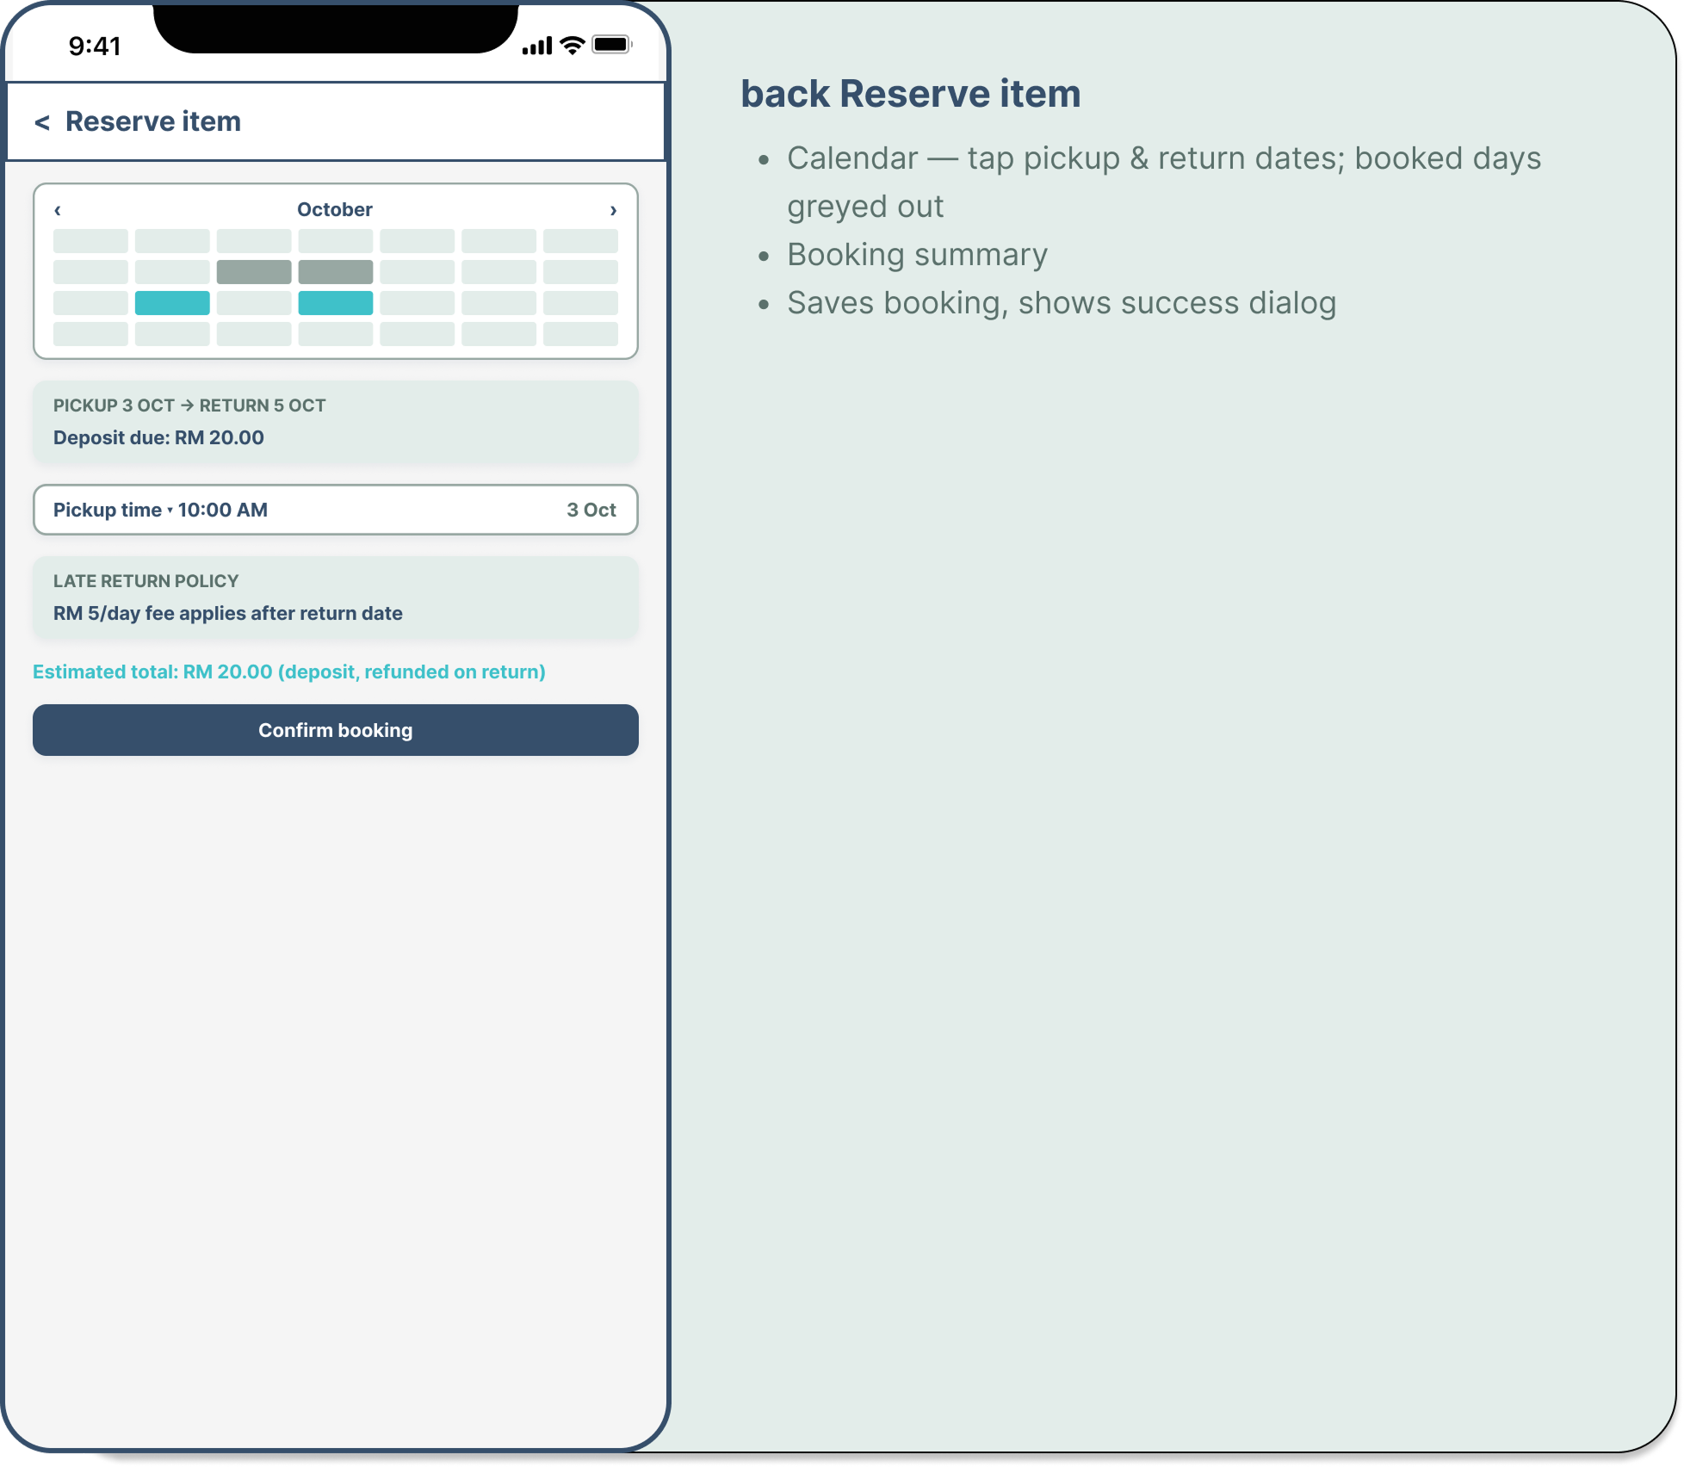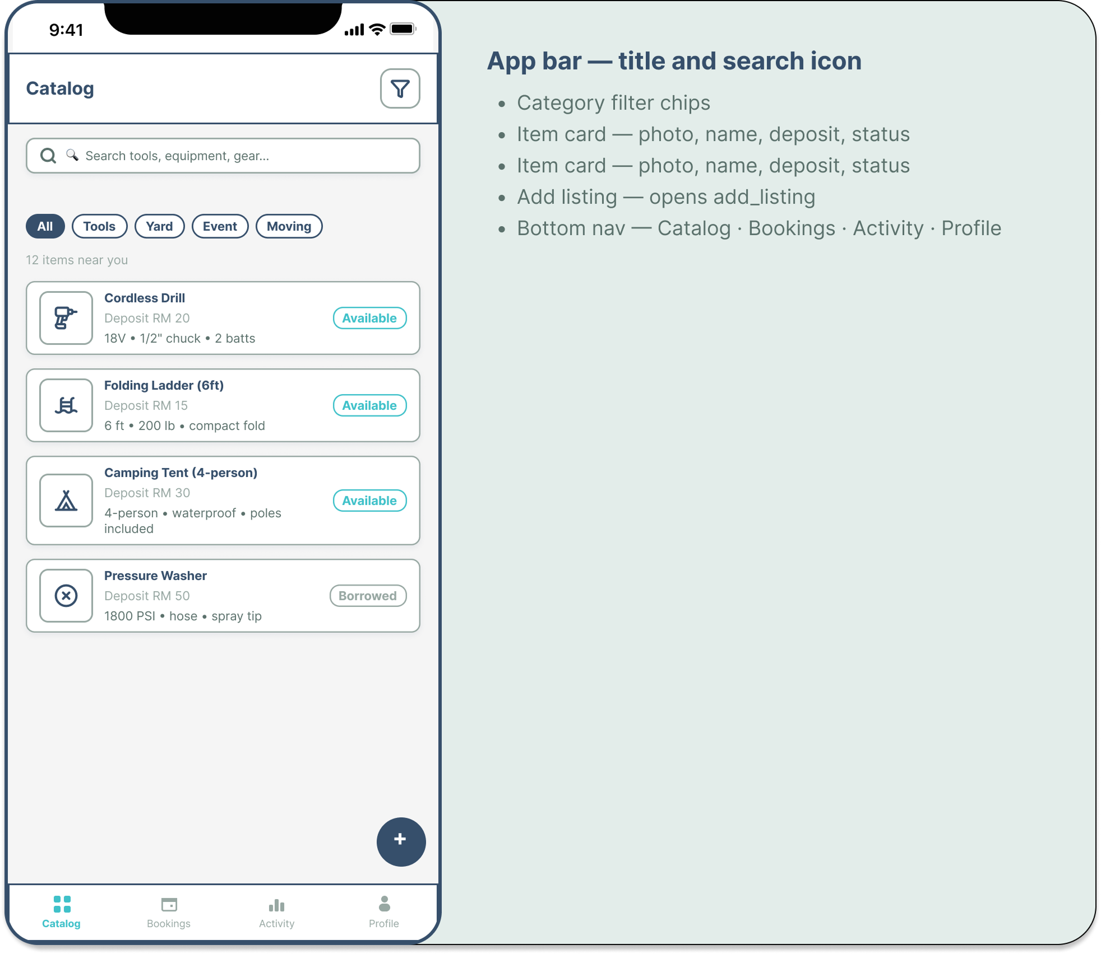

- Combine the activities designed above with the navigation based on the screen maps to form a complete wireframe of your application.
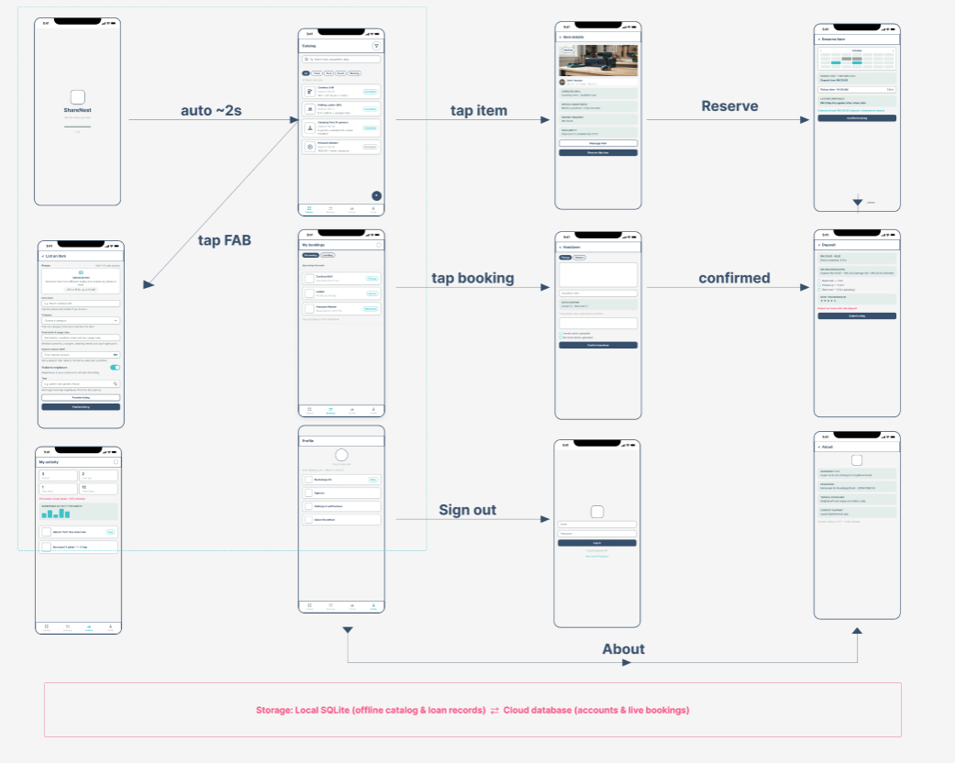

Submission:
Date: 2 October 2026, 17.00pm
Submission method: Online

